

Committee for the Evaluation of Political Science and International Relations Programs

Bar Ilan University
Department of Political Studies
Evaluation Report

September 2011
Contents

Chapter 1: General Background 3
Chapter 2: Committee Procedures 4
Chapter 3: Executive Summary 5
Chapter 4: Evaluation of the Department of Political Studies, Bar Ilan University 6
Chapter 5: Recommendations 15

Appendices:
Appendix 1: The Committee's letter of appointment
Appendix 2: Schedule of the site visit

Chapter 1: General Background
During its meeting on October 7, 2008, the Council for Higher Education (hereafter: CHE) decided to evaluate departments in the fields of Political Science and International Relations.
Following the decision of the CHE, the Minister of Education who serves ex officio as a Chairperson of the CHE, appointed a committee consisting of:
- Prof. Thomas Risse, Otto Suhr Institute for Political Science, Freie Universität Berlin, Germany– Committee Chair
- Prof. Gabriel Ben Dor, School of Political Sciences, University of Haifa, Israel
- Prof. Benjamin Jerry Cohen, Department of Political Science, University of California, Santa Barbara, USA
- Prof. Abraham Diskin, Department of Political Science, Hebrew University of Jerusalem, Israel and Lauder School of Government, Diplomacy, and Strategy, Interdisciplinary Center, Herzliya, Israel
- Prof. Galia Golan, Lauder School of Government, Diplomacy and Strategy, Interdisciplinary Center, Herzliya, Israel
- Prof. Ellen Immergut, School of Social Sciences, Humboldt University Berlin, Germany
- Prof. Robert Lieber, Department of Government, Georgetown University, USA
- Ms. Marissa Gross, Coordinator of the Committee on behalf of the CHE.
Within the framework of its activity, the committee was requested to:
*Examine the self-evaluation reports, which were submitted by institutions that provide study programs in Political Science and International Relations.
*Present the CHE with final reports for the evaluated academic units and study programs – a separate report for each institution, including the committee’s findings and recommendations.
*Submit to the CHE a general report regarding its opinion as to the examined field within the Israeli system of higher education with recommended standards.
The Committee's letter of appointment is attached as Appendix 1.
The first stage of the quality assessment process consisted of self-evaluation, including the preparation of a self-evaluation report by the institutions under evaluation. This process was conducted in accordance with the CHE’s guidelines as specified in the document entitled “The Self-Evaluation Process: Recommendations and Guidelines” (October 2008).

Chapter 2: Committee Procedures
The Committee held its first formal meetings on February 15, 2011. At this meeting committee members were given an overview of higher education in Israel and a description of the Israeli CHE. They also discussed Political Science and International Relations programs in Israel and fundamental issues concerning the committee's quality assessment activity. Committee members had received copies of the departmental reports before this date.
During February 2011 committee members conducted full-day visits to three institutions whose programs the committee was requested to examine: Academic College of Tel Aviv Yaffo, Bar Ilan University and Tel Aviv University. In May 2011, committee members visited the University of Haifa, Open University, Ben Gurion University and the Interdisciplinary Center.
This report deals with the Political Studies Department at the Faculty of Social Studies at Bar Ilan University. The Department of Political Sciences was founded in 1962 and originally only offered B.A. degrees in comparative politics. In the 1970s, the department expanded to offer M.A. and Ph.D. degrees. During the 2009-2010 school year, 752 BA students, 450 Master's students, and 66 doctoral students were enrolled in the Department. In the 2011-2012 academic year, the Department will have 28 tenure track faculty.
The Committee's visit to Bar Ilan University took place on February 20-21, 2010.
The committee spent two days of intensive meetings. It also had an opportunity to see the libraries and other facilities, and meet with appropriate administrators, tenure and tenure-track faculty, adjunct faculty, and BA, MA and PhD students. We thank the appropriate individuals for their involvement in our proceedings. Their input allowed us to explore many of the issues raised in the self-study report.
The schedule of the visit, including the list of participants representing the institution, is attached as Appendix 2.
Chapter 3: Executive Summary

- The Department contributes in an outstanding way to the University’s mission of general excellence in research and teaching, the promotion of studies and research of the Jewish heritage, and of making a contribution to Israeli society. We congratulate the Department for its extremely dedicated faculty which has to work under sometimes adverse conditions, for its very diverse and enthusiastic student body, and for its terrific and accomplished alumni.
- The Department of Political Studies needs to develop an overall strategic plan that analyses its strengths and weaknesses, and pinpoints potential areas of opportunity. The Department should emphasize 3 to 4 areas of specialization at the expense of others. One area with which to start might be ‘religion and politics.’ A second core area could be security and military studies, but with a broader and more modern focus than just defense issues.
- The Department and the leadership of Bar Ilan University should overcome their history of mutual distrust and apparent lack of communication. The Department needs to define its hiring priorities in light of the coming retirements and its areas of core specialization. It then needs to have confidence that, if it is successful in recruiting excellent candidates in these specialties, the University will indeed appoint these persons.
- The deteriorating infrastructure of the Department and the unsatisfactory situation of the library ought to be remedied immediately. The University must invest major resources to renovate the building in which the Department is housed or else move the Department to a more modern and better equipped location. Each core faculty member should be equipped with one office including up-to-date computer facilities.
- We recommend that core faculty teach the introductory courses in the BA program and that a sufficient number of teaching assistants for large introductory courses are employed. The number of courses in political economy and in public administration/public policy should be increased. An internship program should be implemented as a regular part of the BA program. The MA in Political Communications should be established as a joint program of the School of Communications and the Department of Political Studies. Funding opportunities for PhD students should be improved and the existing resources be allocated more efficiently.
- Promotion and tenure criteria for faculty should be spelled out as clearly and transparently as possible and the promotion and tenure process should not take longer than one academic year at most. The positions of senior instructors should be abolished and suitably qualified instructors be promoted to tenure-track positions. The number of adjunct faculty should be reduced and the remaining adjuncts be integrated more fully in the Department.
- The Research Authority of the university should be more active in familiarizing faculty with funding opportunities for research grants. The Department and the University as a whole should develop an incentive system to help faculty with the grant application process. The publication record of faculty members should enter into a merit-based allocation system for resources to individual faculty in order to provide additional incentives for publishing in top ranked journals and with major university publishers.
Chapter 4: Evaluation of the Department of Political Studies, Bar Ilan University

* This Report relates to the situation current at the time of the visit to the institution, and does not take account of any subsequent changes. The Report records the conclusions reached by the Evaluation Committee based on the documentation provided by the institution, information gained through interviews, discussion and observation as well as other information available to the Committee.

4.1 Mission, Goals and Aims
Bar Ilan University defines its mission in terms of three themes: general excellence in research and teaching; the promotion of studies and research of the Jewish heritage; making a contribution to Israeli society. In line with this mission, the Political Studies Department is committed to excellence in research and teaching, and focuses on researching and communicating the impact of political forces on society. In contrast to other political science departments, Jewish studies are a required part of the curriculum, and through its structured programs, the Department makes a contribution to Israeli society by providing continuing education and a means of social mobility. In addition, the Department is open to foreign students and an ethnically and religiously diverse student population and provides support to these various groups.
The Department and Bar Ilan University as a whole are now first emerging from a period of frozen budgets, at the same time as the Department is slated to lose a significant portion of its faculty through retirements. This generational transition could provide a window of opportunity for the Department to re-structure. But for the University and the Department to be able to manage this crisis successfully, a framework for joint action will be necessary. The Department needs to develop an overall strategic plan that analyzes its comparative strengths and weaknesses, and pinpoints potential areas of opportunity. A call for general excellence in research and teaching is not sufficient for such a strategic action plan. We recognize that the Political Studies Department has had a tradition of great intellectuals, but today comparative advantage is the basis of resource allocation within and between universities. The department must come to terms with the need to make choices, and to emphasize certain areas of specialization at the expense of others.
Obviously, the feasibility of such a plan depends upon the availability of job candidates in the indicated areas and on the attractiveness of the Political Studies Department at Bar Ilan University to those candidates, and these points should be considered as an integral part of the hiring strategy. At the same time, however, the Department needs to have confidence that if it indeed defines its areas of core specialization, and is successful in recruiting excellent candidates in these specialties, that the University will indeed appoint these persons. Thus, a sort of social contract and climate of trust is required. The Rector has indicated that if excellent candidates are brought before him, he will provide the budgetary lines for these appointments. He has also made a commitment to beginning a process of dialogue with the Department to clarify this policy.
These are first steps, and we recommend the Department to immediately begin drafting such a planning document and the Administration to begin the dialogue and to find ways to gain the trust of the Department that successful searches will indeed culminate in timely appointments.
As a committee, we do not feel it is our role to draft such a plan for the Department. We can, however, indicate that one fruitful area with which to start might be ‘religion and politics.’ The Department already has strength in this area, and it is a growth area, one which is also quite in line with the Department and University’s mission and profile. It is also an area with tremendous potential for research funding and publication prospects of which the Department should make sure to take full advantage. This core area could be expanded in a number of directions, including ethnicity and politics, women and politics, and the like. A second area of strength could be military and security studies. Here, however, the Department must give some thought about the specific approach and direction in this area and how to modernize it (to consider, say, natural or ecological disasters), given the competition from other security programs and in light of the prominent scholars in this area who will retire. Altogether, the Department needs to come up with 3 or 4 areas of specialization. This certainly does not mean that fundamental knowledge in the key areas of political science already stressed by the Department should be neglected or that excellent appointments should not be made in the standard fields. But a strategic plan should be used to set the priorities for the coming years. This is all the more urgent, as we were told that communication studies and political science are bound to split up in two separate departments.
Related to the overall strategic plan, we also recommend development of a more coherent plan for graduate education including the MA and PhD programs.

4.2 The Study Program
The BA Program
In general, the BA study program is not easy to figure out, because the credit system used is a bit perplexing, given that in certain cases the credits apparently reflect the number of hours spent in the classroom per week, but in other cases they do not, and the deviations do not seem consistent. We recommend development of a unified credit system similar to that of other Israeli universities.
Still, it appears that the number of courses taken by the students during their undergraduate studies is quite similar to the accepted norm in the country (more or less 120 hourly points for three years). The Jewish studies requirement, compulsory for all students, is in addition to this, more or less in lieu of the general studies requirement customary in some of the other universities.
One striking feature of the program is that the vast majority of the introductory courses are taught by junior faculty, for the most part including adjunct faculty, who, by the nature of their appointment, are not part of the core faculty of the Department. While this “saves” the time and the energy of the senior faculty for advanced courses and graduate supervision, the lack of the opportunity of first and second year students to be exposed to instruction by the most senior members of the department detracts, inevitably, from the quality of the teaching on that level. The head of the Department has informed us that he and his colleagues are aware of this deficiency, and that they are very much dedicated to the effort to correct it. We strongly encourage the Department to change its practice and to have regular, core faculty teach the introductory courses.
It also appears that, due to budgetary constraints, the number of teaching assistants in the large introductory courses is being drastically reduced. This will have damaging consequences for the quality of future undergraduate teaching. We strongly recommend, therefore, an effort to ensure the continued employment of a sufficient number of teaching assistants.
The third year advanced seminars, are a critically important part of the program, both for general reasons and for the fact that this is the opportunity for the students to come into direct and intensive contact with the senior faculty. However, the number of the seminars is not quite clear from the description in the evaluation report, and the way in which the credits are allocated to the various seminars is not entirely clear, either. We recommend that the Department straighten this out and to provide a critical mass of advanced seminars.
The absence of the entire subject of Political Economy is striking, and puzzling in the light of the centrality of this field in modern Political Science. Despite the evident interest of students in the field of Public Administration and Public Policy, there are also very few people specializing in this field. In addition, there is a small number of courses in the entire field of Comparative Politics, a fundamental component of the discipline. Also, some of these are not really in Comparative Politics as such, but rather deal with the political system of selected countries only. We recommend, therefore, to increase the courses in (international) political economy, in public administration and public policy, and to make sure that the courses in comparative politics truly deal with their subject matters from a comparative perspective.
The Department has had a large and strong program in Political Communications, a distinct asset over the years. We have been informed that there is now going to be an independent School of Communications, which is to secede from the Department of Political Studies. At the same time, the teaching of political communications in the Department of Political Studies is to continue as well. We wonder how that is going to work with the establishment of the separate new school, and how that is going to affect the ability of the Department to continue its own political communications program on the highest possible level of quality. We, therefore, recommend discontinuation of political communications courses in the Department of Political Studies on the BA level. Instead, political studies students should be allowed to take electives in the new School of Communication. Among other advantages, this would allow the Department to allocate more resources to its areas of core specialization.
Some faculty members emphasized the quality of teaching in the Department, and the friendly atmosphere which prevails in it, highly appreciated by the students. This is reflected in the high grades given to the members of the Department in the student evaluation forms. Some of the undergraduate students complain that they miss, during their course of studies, a more direct contact with the realities of Israeli politics, something that could be acquired through workshops or internships. The existing project of simulation (introduced ad hoc in one introductory course) which was highly praised by all participants might be the right step in that direction. In addition, we recommend adding a third year internship program as a regular part of the BA program.
The written evaluation report shows that there is a missing link in the chain of grades, which is to say, no one gets a grade between 65 and 69. It is not clear to us whether this is a matter of policy, or some strange coincidence.

Graduate Programs
As to the MA programs, there are currently three different programs, a thesis track with 14 credits of classes and an obligatory master thesis as well as a non-thesis track involving 22 credits of classes. Finally, there are so-called “structured degree” programs offered to various sectors such as the IDF and the Israeli government.
The existence of these “structured” programs is to be commended for the service they render to various sectors of Israeli society in need of more intensive higher education. The committee was informed that the tendency now is to merge these programs with the regular program of studies. This being the case, there is a question as to how the quality of the program in general will be maintained once the two populations merge in the same classes. Experience of other universities which have undergone similar changes shows that there is a problem of quality control in these cases, and it will be necessary for the Department in Bar-Ilan to be very conscious of this need. The people in charge recognize the difficulties, and they wish to proceed slowly and cautiously. We agree with this cautious approach and want to express our grave doubts about the advisability of such a merger of the programs.
We were also told that the MA program in Political Communication will remain in the Department of Political Studies as long as the new School of Communications is approved to offer only BA studies. It will apparently be operated jointly by the two entities. If that is the case, we recommend that the MA in Political Communications be established as a joint program of the School of Communications and the Department of Political Studies so as to enhance the synergies between the two institutions.
As to the thesis track MA program, we were told that quite a few MA students apparently find it very difficult to find supervisors for their theses. In addition, we have some major concerns here which, however, are not specific to the Department of Political Studies or to Bar Ilan University, but to Israeli universities in general. In general, the MA program features a very large investment in the writing of the thesis, and much less than desirable in the courses themselves. This seems appropriate for the doctoral program more than for the MA program. In our view, MA and PhD programs at Israeli universities are in general need of reform, and we make a recommendation in our general report to MALAG.

4.3 Faculty
The faculty appears to be well qualified, though the overall level is not entirely uniform. The younger faculty may be introducing somewhat greater diversity of methodology and academic approaches. The atmosphere among the faculty is extremely congenial and pleasant with regard to relations with each other and with the head of the department. Their sense of loyalty to the Department and pride with regard to the history of the Department were notable. However, morale of the faculty is quite low and the subject of concern. This apparently is the result of a number of factors:
- the recent (now ended) freeze on promotions for budgetary reasons;
- the perception that criteria for promotion are unclear and often changing;
- uncertainty regarding the future of the Department in view of the pending retirement of one-third of the faculty;
- a sense that the University is shifting priorities in planning with regard to funding, facilities, personnel, and the like, to the natural sciences at the expense of the social sciences. (We were told very emphatically by the Rector that this is definitely not the case, but perceptions matter and point to a lack of communication between the University leadership and the Department.)
Thus they felt undervalued and at a growing disadvantage for the pursuit of academic excellence in Political Studies. They did not complain but rather accepted with good humor the extraordinarily cramped infrastructure of the Department, specifically the fact that two to three lecturers have to share one office.
Judging from the comments received by the committee, it would appear that there is a history of considerable distrust between the Rector’s office and the Department concerning such vital matters as faculty appointments and tenure decisions. Uncertainty about applicable criteria or the availability of line positions made it difficult for individuals or the Department to plan their future effectively. We are happy to see that with the recent appointment of a new Rector, much is being done to mitigate these problems by promoting more transparency and less bureaucracy in decision making, and we urge that both the Department and the Rector continue to promote improvements along these lines.
In this context, there seemed to exist another tension between the Department and the Rector. The latter insists on promotion and hiring first and foremost on the basis of academic excellence in research, while the Department emphasized that given the expected wave of retirements, the teaching needs are essential. The Rector, however, emphasized that additional positions could be allocated to the department on the basis of research excellence even before the expected retirements materialize, if the department’s candidates prove to be better researchers than those of other departments. In our opinion, it would help greatly if, on the one hand, the Department does more to develop a strategic plan for future faculty appointments while, on the other hand, the Rector gives firmer assurance that appointments will definitely be made available when qualified candidates are identified (see above).
In addition, we recommend
- the introduction of a mentor system for younger faculty so as to guide them in planning their academic efforts, in particular, how to seek research grants, and
- the organization of teaching workshops to improve the teaching where needed (particularly in the case of some who excel at research but may be weaker at teaching).
Yet, neither these conditions nor the low morale appears to be affecting faculty relations with students; the faculty seem genuinely open to – and enjoy - interacting with the students.
An important issue raised in our discussions with faculty concerned the length of time in each rank and the length of the procedure for promotions (sometimes up to three years), particularly with regard to junior faculty (senior instructors) and lecturers. This situation appeared to be most acute for young women. In fact, surprisingly for Bar Ilan, which has been quite advanced in the area of Women’s Studies, the Department has an unusually low number of tenure track women. We have been informed by the Rector that this situation, along with the overly large number of adjuncts, is already being remedied as a result both of the ending of the personnel freeze and of changes in policy regarding non-tenure track positions. We nevertheless recommend strongly
- to streamline the promotion and tenure procedures which should take no longer than one academic year at most;
- to abolish the positions of senior instructors and to promote instructors who seem to be extremely qualified, to tenure-track positions of lecturers as soon as possible;
- to decrease the number of adjunct instructors in the Department and to integrate the remaining adjunct faculty more fully into the life of the Department;
- to give greater attention to the matter of possible gender bias and to make a much more aggressive effort to hire female faculty.
We also recommend that the family responsibilities of younger staff be taken more seriously. For example, consideration should be given to the creation of day care facilities at the University. In this connection, it was positively noted that the University has added a year to the length of time allowed for promotion of women to Senior Lecturer.
With regard to Adjunct faculty, we understand (and support the decision) that their numbers are to be reduced, but adjuncts themselves are concerned that they are not considered when candidates are considered for tenure track positions. While they can, of course, respond to tenders issued by the department, they are at a disadvantage for having been employed only 8 months a year and often teaching 16 hours a week so they are forced to find supplementary income and have little time for the research and publishing necessary to obtain a tenure-track position. While this appears to be a general problem in Israeli academia which we will address in our general report, the Department and Bar Ilan University in general must increase their own efforts to improve the working conditions of adjunct faculty. In particular, more office space should be provided to adjuncts as well as more designated spaces for them to meet with students.

4.4 Students
Students are very satisfied with the atmosphere and warmth of the University and the Department. This was the case for all the students with whom we met at the BA, MA and PhD levels. We congratulate the Department and Bar Ilan University in general for their efforts to make their students feel at home which is a major asset in an increasingly competitive academic environment. Indeed many of the graduate students chose to stay at Bar Ilan for this reason. Nonetheless, it is recommended that the Department seek graduate students from other institutions more actively.
Undergraduate students seemed quite satisfied with the faculty and program of study, though they felt that more courses in international relations were needed. The teaching level of the department was generally praised. What was clearly missing – and sought – were initiative, projects or programs that would involve students more in public or political life outside the classroom, for example, internships, field trips, empirically based research and so forth (see above).
Students spoke warmly of the accessibility and openness of the faculty, although both MA and PhD students expressed difficulty in finding faculty to supervise their theses, because lecturers are too busy (see above). We also found that supervision of MA and especially PhD theses is sometimes inconsistent. That is, aside from an annual report, there are no obligations or timelines for students to work with or consult their advisors. Such scheduling is left up to the individual advisor to determine, thereby leaving matters in some cases up to the student to initiate consultation with the advisor without clear deadlines. We, therefore, recommend that the Department works out a clear advising schedule for supervisors and students.
PhD candidates are not fully funded; indeed there do not seem to be many scholarships large enough to enable the students to devote full time to their thesis. With regard to fellowship and the like, it was not clear to us according to which criteria and priorities these fellowships are being allocated (e.g. merit-based; need-based; a combination of both?). This is a general problem of Israeli universities which we will bring up in our general report to MALAG. We nevertheless recommend that the Department and Bar Ilan University as a whole see to it how funding opportunities for PhD students in particular can be improved and how the existing resources can be allocated more efficiently.
We also recommend that that an orientation be provided early in the graduate program to direct students to available funding and other practical matters. Indeed, general advising must be improved at all levels, PhD, MA and BA. Students at all levels also suggested the creation of a career guidance office for the Department (in addition to the University-wide career office). Last but not least, students at all levels felt that the Library did not meet their needs (see below).
Alumni expressed great satisfaction with their time in the Department. Again, this is a major asset for the Department and the University as a whole, as well as an opportunity for students seeking careers after graduation. Our recommendation is to involve alumni more in the University and to improve the networking opportunities of students with alumni. They appear willing to contribute, in many ways; and the University should consider building an active alumni association.

4.5 Research
The self-evaluation report declares that: “the Department of Political Studies at Bar Ilan University is a research oriented department where faculty members are engaged actively in research and in guiding and mentoring research students.” Our general conclusion is that while the devotion to serve a large number of PhD (and MA) students is evident, there is a room for improvement in the scope and quality of faculty research.
Research resources are not impressive. At the same time, many faculty members are not applying for external grants. According to the self-evaluation report, ten faculty members did not apply for any grants during the five years examined, and only three averaged one or more applications per year. Only 30% of the faculty applied more than once during the five years covered by the report. Such activity improved recently, but it is still quite limited and the rate of success is not impressive.
There seems to be a need for a more pro-active research authority of the university, and for additional incentives to faculty members who are associated with both quality research and involvement in applications for external grants. It seems to us that many faculty members are not aware of funding opportunities for external grants outside the rather limited resources of the Israeli Science Foundation. In particular, the research authority must be much more active in familiarizing faculty with funding opportunities provided, e.g., by the European Union (both European Research Council and Framework Programs funded by the European Commission) and by German funding agencies in particular. At the same time, the Department and Bar Ilan University as a whole should develop an incentive system such as additional funding in case of successful applications, start-up grants to help faculty with the application process, and the like. Acquisition of research grants should also be an explicit part of the criteria for promotion and tenure.
In general, we encourage the formation of research groups and increased research collaboration among the faculty, which would also help in securing external funding.
As to publications, the self-evaluation report states that in the 2004 to 2008 period, faculty members authored 17 books, 164 articles in peer-review journals and 108 book chapters as well as serving as the editor for 20 books. According to faculty CVs, this intensive activity continued after 2008 and the publication record of the Department as a whole is on an upward curve. Nevertheless, the majority of faculty does not seem to publish in leading political science journals. In general, the level of PhD dissertations and the production of refereed publications are very reasonable but not yet outstanding. The Dean and other university authorities recognize this phenomenon. Once again, we see some room for improvement here and recommend that the publication record of faculty members should enter into a merit-based allocation system for resources to individual faculty in order to provide incentives for publishing.
As to research and methods training in the graduate programs, we find the level adequate on the whole. The MA study program requires students to participate in several “research” courses: Foundations of the Scientific Research (2 credits), Scientific Writing Workshop (2 credits), Advanced Qualitative Research Methods (1 credit) and Advanced Quantitative Research Methods (1 credit). In general, MA students expressed their satisfaction with the methods courses. Nevertheless, it seems that a couple of instructors in methods courses, who are highly appreciated by students and who are active researchers do not enjoy tenured positions. A number of PhD students expressed dissatisfaction with their training in quantitative methods.

4.6 Broader Organizational Structure
The Department of Political Studies is one of some twelve departments and schools that come under the direct authority of the Dean of the Faculty of Social Sciences, who in turn answers to the University Rector. The Department is supervised by the Chair, who is responsible for the day-to-day running of the Department, developing and updating study programs, implementing the study programs at the Department, and supervising the faculty. With the assistance of several deputies and advisors and a number of functional committees, the Department Chair effectively manages all matters concerning the Department’s curriculum and its development, as well as faculty recruitment and promotion.
Overall, the organizational structure within which the Department operates appears to function reasonably well, with one exception. That concerns the culture of relations between the office of the Rector and the Department on which we have commented above.
4.7 Infrastructure
We find the physical infrastructure available to the Department to be strikingly inadequate and a disgrace for an academic unit of this size. The Department is crammed into little more than one floor of a badly aging building, with 2-3 faculty members (of all ranks) assigned to individual offices and with classrooms that seem worn and uninviting. The deteriorating and uninviting infrastructure of the Department ought to be remedied immediately. We are quite convinced that more than uninviting working conditions considerably contribute to the low morale of the faculty noted above. The University must invest major resources to renovate the building in which the Department is housed or to move the Department to a more modern location.
Equally unsatisfactory is the library, which appears to have been starved of sufficient resources for far too long. While students appear to have a reasonable degree of access to journals and relevant databases via the internet, the library’s book collection seems very old, stacks are cramped, and computer stations are greatly outmoded. Students tell us that the facility is not conducive to reading and complain about the fact that the library is not open evenings. More resources must be made available to the library if the Department’s educational function is to be served adequately.

4.8 Quality assessment
The Department appears to have a well developed set of internal mechanisms for quality assessments, including regular examination of courses and study content and regular teaching surveys. We see no need for further recommendations in this area.

Chapter 5: Recommendations
5.1 Congratulatory Remarks
The committee wants to congratulate the Department of Political Studies and Bar Ilan University for producing an excellent evaluation report as well as for their very frank and detailed exchanges with us during the two days of the site visit. Moreover, we feel that the Department contributes in an outstanding way to the University’s mission of general excellence in research and teaching, the promotion of studies and research of the Jewish heritage, and of making a contribution to Israeli society. We congratulate the Department for its outstanding and extremely dedicated faculty which has to work under sometimes adverse conditions, for its very diverse and enthusiastic student body, and for its terrific and accomplished alumni. These are major assets for the Department to tackle the challenges of the future.
The following recommendations which we have described in more detail in chapter 4 above, are meant to help the Department to accomplish its mission even better.

5.2 Recommendations
The Need for a Strategic Plan
The Department of Political Studies needs to develop an overall strategic plan that analyses its comparative strengths and weaknesses, and pinpoints potential areas of opportunity. The Department must come to terms with the need to make choices, and to emphasize certain areas of specialization at the expense of others. As a committee, we do not feel it is our role to draft such a plan for the Department. We can, however, indicate that one fruitful area with which to start might be ‘religion and politics.’ This core area could be expanded in a number of directions, including ethnicity and politics, women and politics, and the like. A second core area could be security and military studies, but with a broader and more modern focus than just defense issues. Altogether, the Department needs to come up with 3 or 4 areas of specialization.

The Need for a “Social Contract” between the Department and the University
The Department of Political Studies and the leadership of Bar Ilan University must work together to overcome its history of mutual distrust and apparent lack of communication. We recommend a sort of social contract: The Department should come up with a planning document which must include hiring priorities in light of the coming retirements and its areas of core specialization. It then needs to have confidence that, if it is successful in recruiting excellent candidates in these specialties, the University will indeed appoint these persons. The Rector has indicated that if excellent candidates are brought before him, he will provide the budgetary lines for these appointments. He has also made a commitment to beginning a process of dialogue with the Department to clarify this policy. This dialogue must begin immediately. We are happy to see that with the recent appointment of a new Rector, much is being done to promote more transparency and less bureaucracy in decision making, and we urge that both the Department and the Rector continue to promote improvements along these lines.
The Need to Improve the Infrastructure and the Library Resources
The deteriorating and uninviting infrastructure of the Department and the unsatisfactory situation of the library ought to be remedied immediately. We, therefore, recommend that
- the University invest major resources to renovate the building in which the Department is housed or else move the Department to a more modern and better equipped location;
- each core faculty member – whether junior or senior – be equipped with one office including up-to-date computer facilities;
- more resources be made available to the library if the Department’s educational function is to be served adequately. This includes renovating the stacks, putting in modern computer stations, and opening the library in the evening.

Improving the Study Program
With regard to the BA program, we recommend
- to change the Department practice and to have core faculty teach the introductory courses;
- to ensure the continued employment of a sufficient number of teaching assistants for the large introductory courses;
- to clarify the allocation of credits to advanced seminars and to provide a critical mass of these seminars;
- to increase the number of courses in (international) political economy as well as in public administration and public policy and to make sure that core faculty is available to teach these courses;
- to make sure that the comparative politics courses include a comparative perspective and not focus only on Israeli politics;
- to discontinue teaching political communications courses in the Department of Political Studies on the BA level and, instead, to allow political studies students to take electives in the new School of Political Communications;
- to implement an internship program as a regular part of the BA program.
With regard to the graduate programs, we recommend
- that the MA in Political Communications be established as a joint program of the School of Communications and the Department of Political Studies so as to enhance the synergies between the two institutions;
- the thesis track MA program be integrated into a restructured PhD program based on the current “fast track” to the PhD option.
- the Department seek graduate students from other institutions more actively.
- the Department work out a clear advising schedule for supervisors and students which might be included in a supervision agreement obligatory for both sides.
- the Department and Bar Ilan University as a whole seek to find how funding opportunities for PhD students in particular can be improved and how the existing resources can be allocated more efficiently.
- an orientation be provided early in the graduate program to direct students to available funding and other practical matters.

For both undergraduate and graduate programs, we recommend
- to improve general advising at all levels;
- to create a career guidance office for the Department (in addition to the University-wide career office);
- to involve alumni more in the University, to improve the networking opportunities of students with alumni, and to institute an active alumni association.

Recommendations With Regard to Faculty and Research
Our most urgent and most important recommendation concerns the need for a strategic plan for the Department as well as a new “social contract” between the Department and the University leadership. We strongly urge to include the faculty in this process at all stages so that the future of the Department in view of the pending retirement of one third of the faculty is no longer uncertain. We are confident that this will raise the morale of the faculty considerably.
In addition, we recommend
- to spell out promotion and tenure criteria as clearly and as transparently as possible so that junior faculty know exactly what is expected of them and where they stand;
- to streamline the promotion and tenure procedures which should not take longer than one academic year at most;
- to abolish the positions of senior instructors and to promote instructors who appear to be suitably qualified, to tenure-track positions of lecturers as soon as possible;
- to introduce a mentor system for younger faculty so as to guide them in planning their academic efforts, in particular, how to seek research grants;
- to decrease the number of adjunct instructors in the Department, to integrate the remaining adjunct faculty more fully into the life of the Department, and to improve their working conditions;
- to make a much more aggressive effort to hire female faculty;
- to organize teaching workshops to improve the teaching where needed.
Finally, with regard to research opportunities and the improvement of the Department’s publication record, we recommend
- that the Research Authority of the university be much more active in familiarizing faculty with funding opportunities for research grants, particularly with regard to the European Union and German funding agencies;
- that the Department and the University as a whole develop an incentive system including start-up grants to help faculty with the application process, the allocation of additional resources in cases of successful applications, and the inclusion of research grants in the criteria for promotion and tenure;
- that the publication record of faculty members should enter into a merit-based allocation system for resources to individual faculty in order to provide additional incentives for publishing in top ranked journals and with major university publishers.

Signed by:


________________________ ________________________
Prof. Thomas Risse, Chair Prof. Gabriel Ben Dor


___________________________ __________________________
Prof. Benjamin Jerry Cohen Prof. Abraham Diskin


_______________________ ______________________
Prof. Galia Golan Prof. Ellen Immergut

Appendix 1: Copy of Letter of Appointment
Appendix 2: Site Visit Schedule
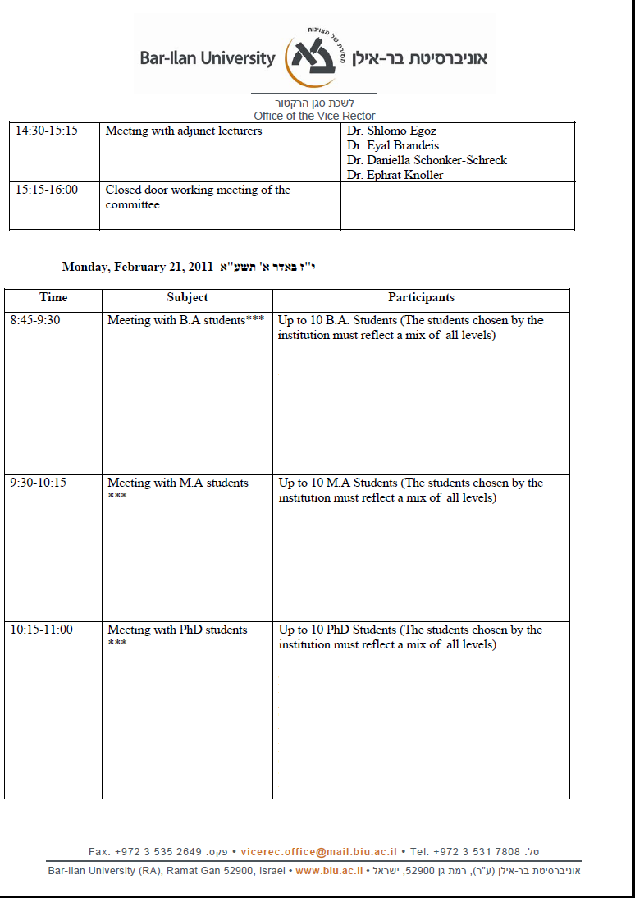
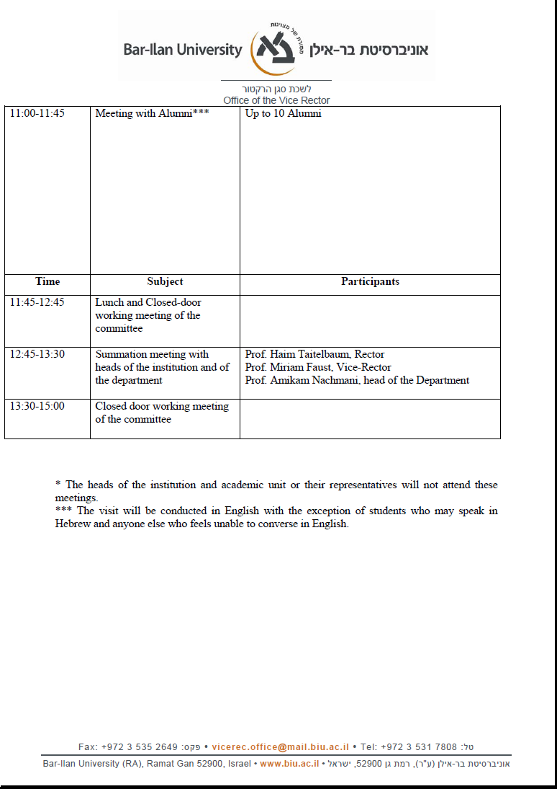

Prof. Gabriel Ben Dor did not participate in the evaluation of the University of Haifa visit.
Prof. Abraham Diskin did not participate in the evaluation of the Interdisciplinary Center Herzliya.
Prof. Galia Golan did not participate in the evaluation of the Interdisciplinary Center Herzliya.
Prof. Ellen Immergut did not participate in the visits of Open University, Ben Gurion University, and Interdisciplinary Center Herzliya.
Prof. Robert Lieber did not participate in the first round of visits.

